TrafficTelligence: Advanced Traffic Volume Estimation with Machine Learning

Category: Artificial Intelligence

# Team Members and Roles

| Name | Role |
| --- | --- |
| Thumati Manasa | ML Model Developer |
| Ummaleti Sasank | Data Collection & Preprocessing |
| Thoran Sai | Model Testing & Evaluation |
| Thota Naga Lokesh | Documentation & Presentation |

# Introduction

## Purpose

TrafficTelligence is an advanced system designed to estimate and predict traffic volume using machine learning algorithms. By analyzing historical traffic data, weather patterns, events, and other relevant factors, TrafficTelligence delivers accurate forecasts and insights to support traffic management, urban development, and enhanced commuter experiences.

## Key Features

* - Preprocessing and analysis of real-world traffic data
* - Deployment of machine learning models for traffic congestion prediction
* - Evaluation of model performance using accuracy, F1-score, and other metrics
* - Interactive user interface for seamless input and output interaction
* - Scalable architecture suitable for smart city applications

# Technical Details

## Programming Language

Python, HTML&CSS.

## Machine Learning Algorithms Used

Linear Regression, Random Forest, XGBoost, etc.

## Dataset Source

CSV-based dataset

## Libraries and Frameworks

* - Pandas
* - NumPy
* - Scikit-learn
* - Matplotlib
* - Flask

## Tools and Platforms

* - Jupyter Notebook
* - Python (Anaconda environment)
* - GitHub for version control and collaboration

# Technical Architecture

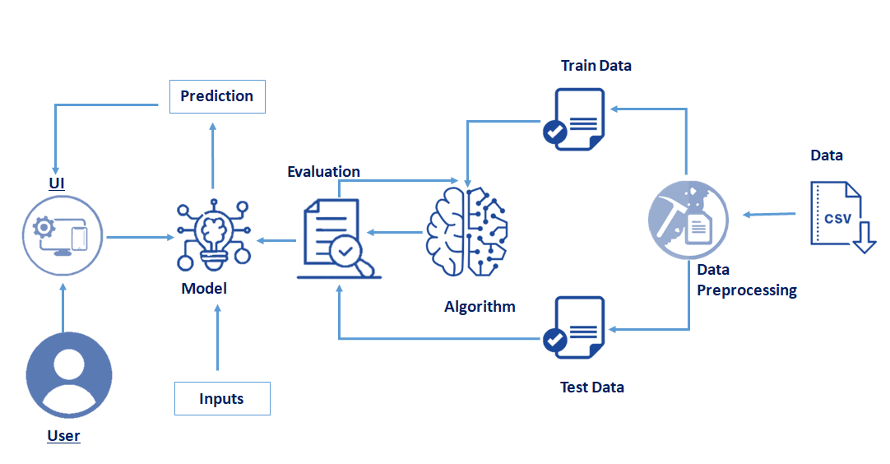

## Workflow Overview

* - User Interface: Users interact with the system via a graphical interface to provide input data and receive predictions.
* - Input Handling: Input data, such as traffic logs in CSV format, is uploaded for processing.
* - Data Preprocessing: Raw data undergoes cleaning, transformation, and splitting into training and testing datasets.
* - Model Training and Algorithm Application: ML algorithms are trained on the preprocessed data. Model performance is evaluated using metrics like accuracy, precision, and recall.
* - Prediction Generation: Trained models provide traffic volume predictions based on new or real-time data.
* - Evaluation and Metrics: Output predictions are assessed using test datasets and evaluation metrics.
* - Visualization: Prediction results and traffic trends are visualized through graphs and dashboards for better user understanding.

# Project Use Case Scenarios

## Scenario 1: Dynamic Traffic Management

Transportation authorities can use real-time traffic volume predictions to adjust signal timings, deploy resources effectively, and reduce road congestion.

## Scenario 2: Urban Development Planning

Urban planners utilize traffic forecasts to design efficient road networks, public transport systems, and commercial zones tailored to predicted traffic needs.

## Scenario 3: Commuter Guidance and Navigation

Commuters and navigation apps use traffic volume estimates to suggest optimal travel times and routes, improving daily travel efficiency.

Output Screenshot

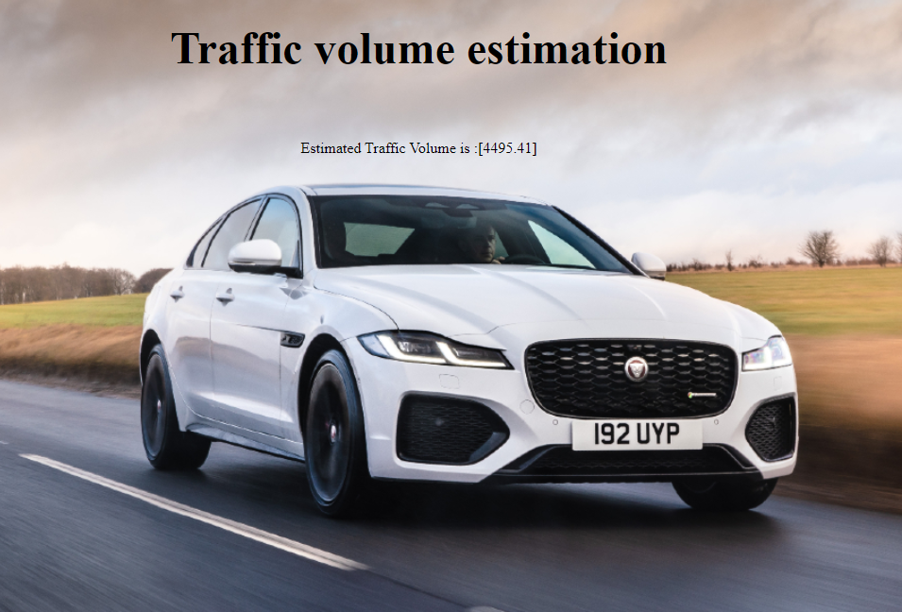

## Description:

The image below represents the output of the TrafficTelligence system after processing traffic-related input data. Once the model runs its predictions based on the input features (such as weather, hour, holiday data, etc.), it estimates the traffic volume accordingly.

## Displayed Output:

Estimated Traffic Volume is: [4495.41]

The output is integrated into a simple yet intuitive user interface, allowing users to visualize prediction results immediately. This makes the system more accessible for non-technical users, urban planners, and decision-makers.